AWS Instance creation proof:

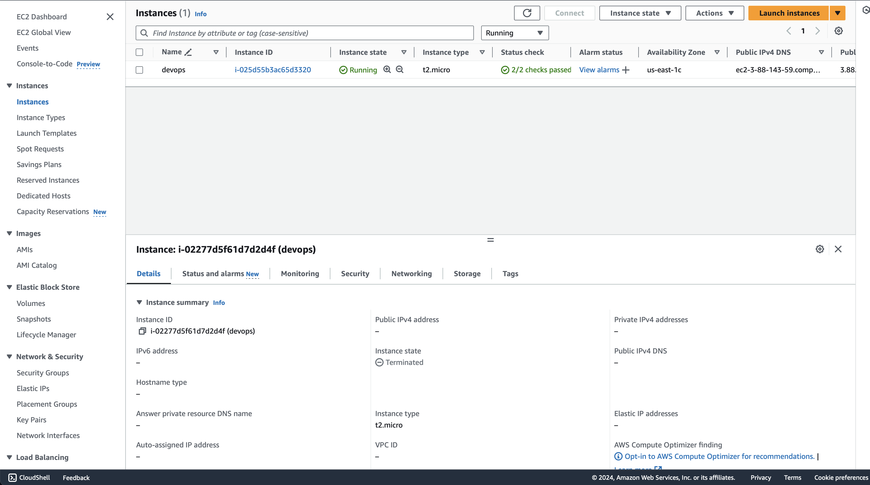

Terminal with certificate (with read-only permissions chmod 400) and SSH command ready, proof:

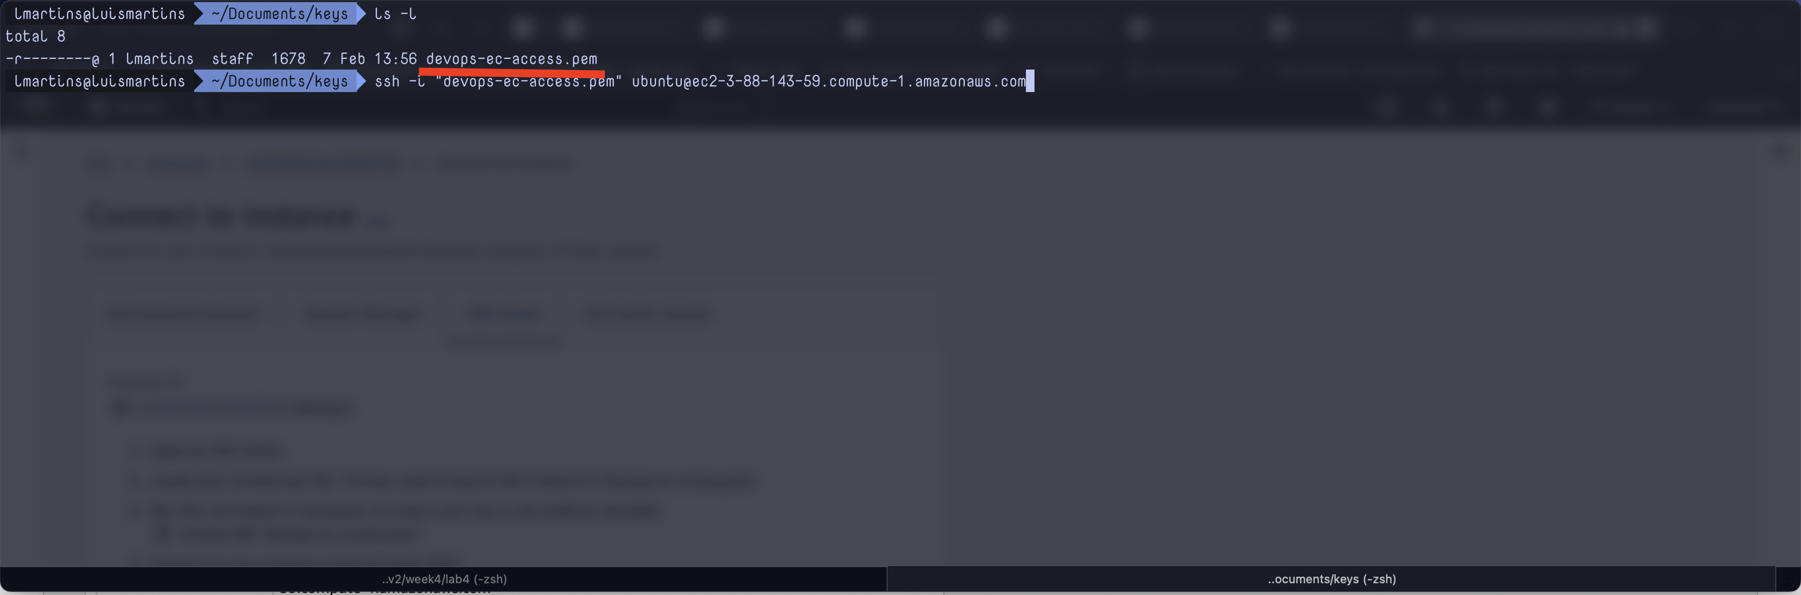

SSH connection proof:

